Object Detection with YOLO
1)For Q1 i will do data agumentation (targeted brightening etc) for my dataset i used to improve model performance in detecting ‘books’ as model detects laptops class good enough but will improve it also
2)For 10 epochs i got following metrics, see results more clearly in runs dir check train5, train52
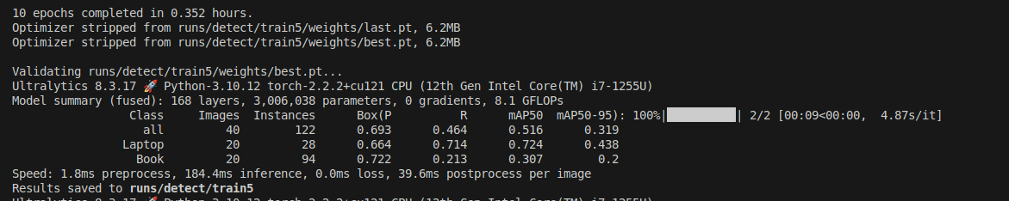
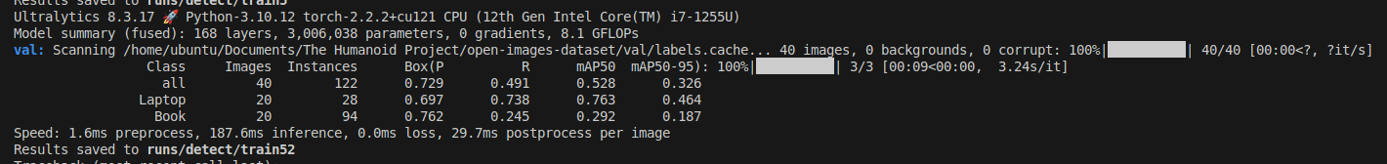
3)For 50 epochs i got following metrics , see results more clearly in runs dir check train7, train72

Note: I have used get_dataset.py to get the dataset i used here(open-images-dataset) from open-images-v7 and split_dataset.py i used to split dataset into train(160) and val(40)

